STUDENT NAME : NGUYEN HOANG MINH

STUDENT ID : 104972886

**VALIDATION FROM validator.w3.org**

Features.html:

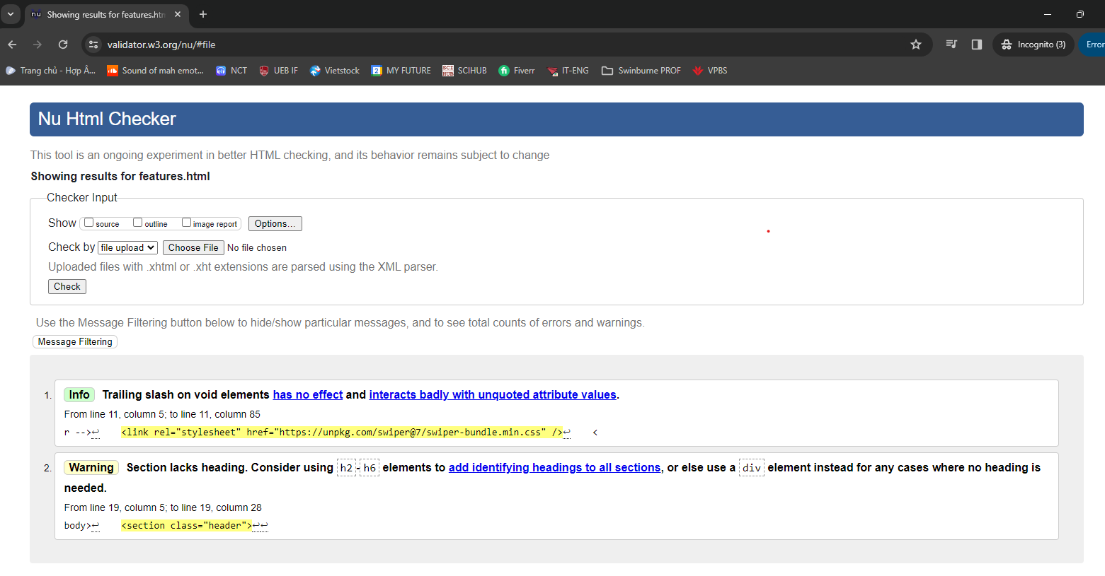

Index.html

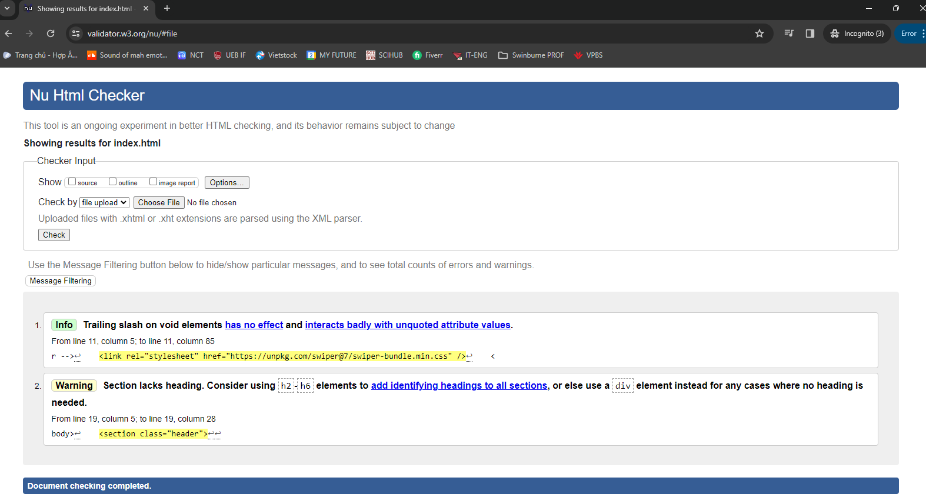

Order.html

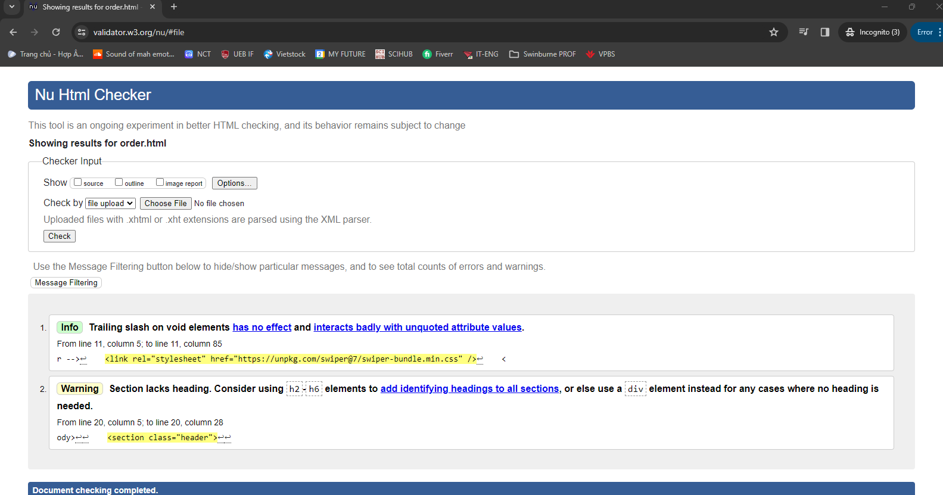

Registration.html

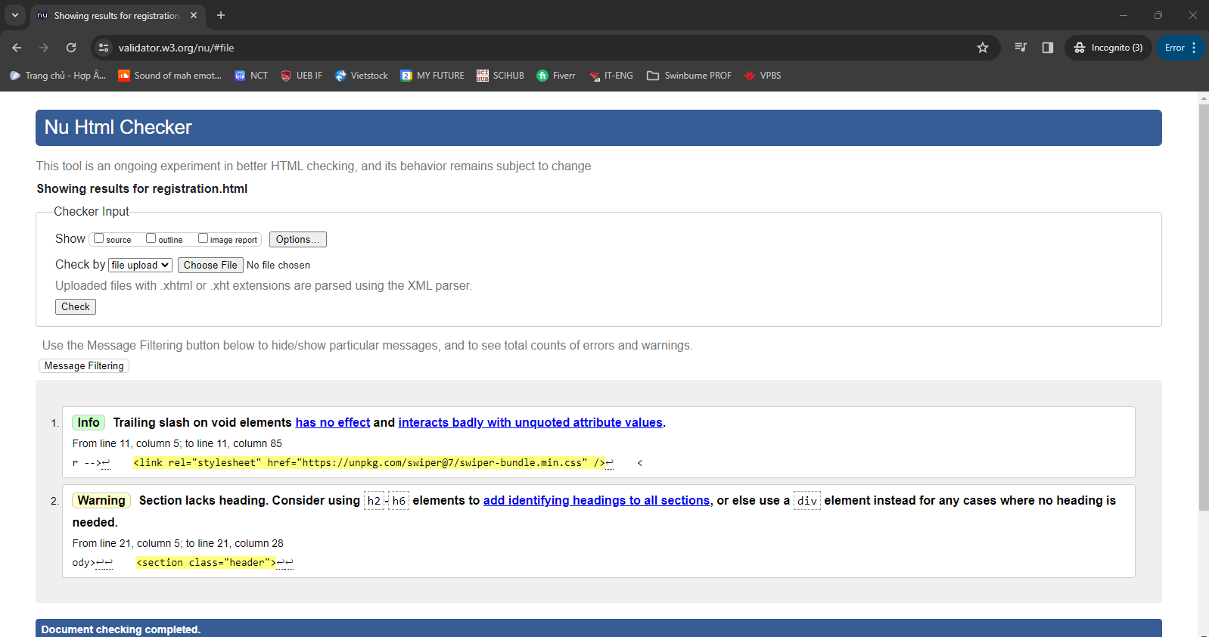

**VALIDATION FROM WAVE Extension:**

Index.html

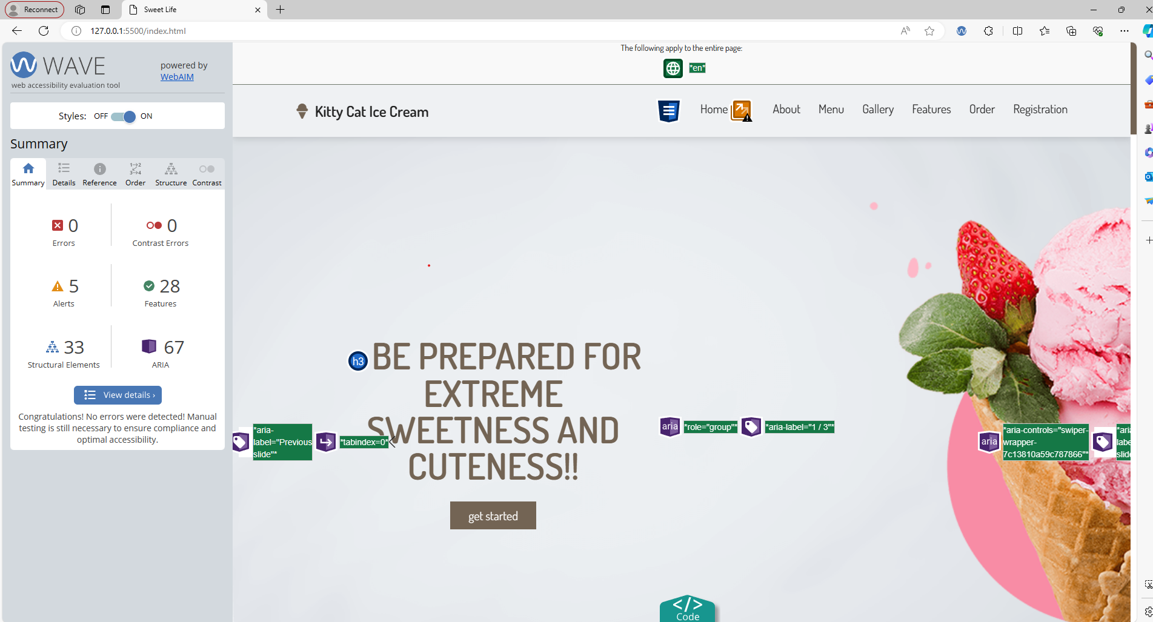

Features.html



Order.html

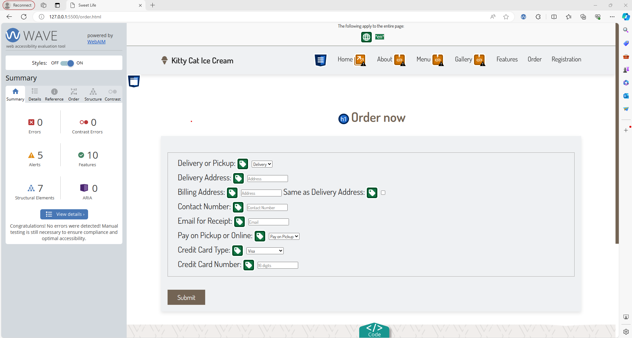Registration.html:

